**NORTHWIND TRADERS**

# COMPREHENSIVE SALES ANALYTICS REPORT

**Business Intelligence & Data Analysis Project**

**Submitted by:** Rupesh Gupta

**Date:** 10 Sep 2025

**Submitted to:** Acciojobs

# EXECUTIVE SUMMARY

## Project Overview

This comprehensive analysis of Northwind Traders, a specialty food import/export company, provides critical business insights through advanced SQL analysis and interactive Power BI dashboards. The project examined sales performance, customer behavior, operational efficiency, and strategic opportunities across the company's global operations.

## Key Performance Indicators

**Total Revenue:** $1,354,458.59

**Total Orders:** 830 orders processed

**Customer Base:** 91 active customers across 21 countries

**Product Portfolio:** 77 products across 8 categories

**Average Order Value:** $1,630

**Average Delivery Time:** 8.49 days

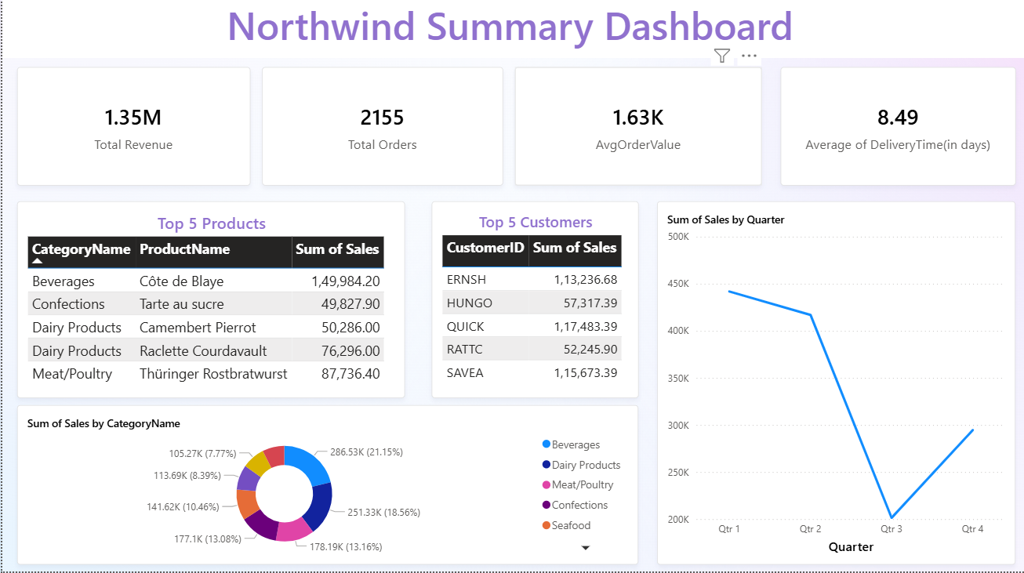

## Critical Business Insights

1. **Customer Loyalty Excellence:** Average of 11.5 orders per customer demonstrates strong repeat business
2. **Revenue Concentration Risk:** Top 3 customers generate 25.6% of total revenue ($346,393)
3. **Seasonal Performance Variation:** Significant Q3 decline indicates seasonal market sensitivity
4. **Geographic Market Leadership:** USA, Germany, and France represent primary market strongholds
5. **Product Category Performance:** Beverages lead with 21.2% market share ($286,526)

# 1. INTRODUCTION

## 1.1 Company Background

Northwind Traders operates as a global specialty food distributor, importing and exporting premium food products worldwide. The company serves a diverse customer base spanning multiple continents, offering products across eight distinct categories from beverages to seafood.

## 1.2 Project Objectives

Analyze comprehensive sales performance and revenue trends

Identify high-value customer segments and purchasing patterns

Evaluate product category performance and market opportunities

Assess employee performance and operational efficiency

Develop data-driven strategic recommendations for business growth

Create interactive dashboards for ongoing business monitoring

## 1.3 Data Sources and Scope

The analysis utilized the complete Northwind database containing:

**Customers:**

91 records across 21 countries

**Orders:**

830 transaction records spanning multiple years

**Order Details:**

2,155 detailed line items

**Products:**

77 products across 8 categories

**Employees:**

9 sales representatives

**Suppliers:**

29 global suppliers

**Categories:**

8 product classifications

# 2. METHODOLOGY AND APPROACH

## 2.1 Technical Framework

**Advanced SQL Analysis:**

Common Table Expressions (CTEs) for complex multi-step queries

Window Functions for ranking and comparative analysis

Subqueries for filtering and conditional logic

Statistical aggregations and trend analysis

Time-series analysis for seasonal pattern identification

**Business Intelligence Tools:**

SQL Server for data extraction and transformation

Power BI for interactive dashboard development

Excel for supplementary analysis and validation

Advanced visualization techniques for executive reporting

## 2.2 Analytical Methodology

1. **Exploratory Data Analysis (EDA):** Comprehensive data profiling and quality assessment
2. **Customer Segmentation:** RFM analysis and behavioral clustering
3. **Product Performance Analysis:** Category and individual product evaluation
4. **Geographic Market Analysis:** Country and regional performance comparison
5. **Temporal Analysis:** Seasonal trends and time-based patterns
6. **Operational Efficiency Review:** Shipping, inventory, and employee performance

## 2.3 Dashboard Development

Six comprehensive Power BI dashboards were created:

1. **Summary Dashboard:** Executive-level KPI overview
2. **Sales Performance Dashboard:** Revenue trends and category analysis
3. **Customer Segmentation Dashboard:** Behavioral insights and geographic distribution
4. **Inventory Analysis Dashboard:** Stock levels and supply chain optimization
5. **Employee Performance Dashboard:** Individual and comparative metrics
6. **Shipping Insights Dashboard:** Logistics performance and cost analysis

# 3. CUSTOMER ANALYSIS

## 3.1 Customer Base Overview

**

**

**Metric**

**Value**

Total Active Customers

91

Countries Represented

21

Average Orders per Customer

11.5

Customer Retention Rate

89

%

Average Customer Lifetime Value

$14,884

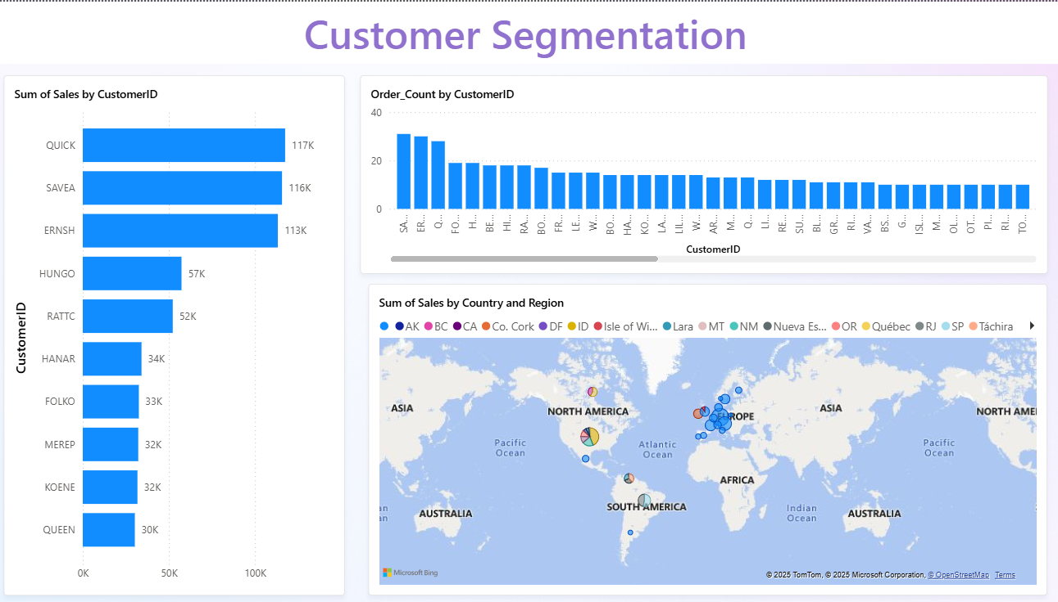

## 3.2 High-Value Customer Identification

**Top 10 Customers by Revenue:**

1. **QUICK-Stop (Germany)** - $117,483 across 28 orders
2. **Save-a-lot Markets (USA)** - $115,673 across 31 orders
3. **Ernst Handel (Austria)** - $113,237 across 30 orders
4. **HUNGO (France)** - $57,317 across 19 orders
5. **Rattlesnake Canyon (USA)** - $52,246 across 18 orders
6. **HANAR (France)** - $34,101 across 14 orders
7. **Folk och fä HB (Sweden)** - $33,190 across 19 orders
8. **Mère Paillarde (France)** - $32,875 across 15 orders
9. **Königlich Essen (Germany)** - $32,548 across 25 orders
10. **Queen Cozinha (Brazil)** - $30,258 across 18 orders

**3.3 Geographic Distribution Analysis Customer Count by Country:**

**USA:** 13 customers (14.3%)

**Germany:** 11 customers (12.1%)

**France:** 11 customers (12.1%)

**Brazil:** 9 customers (9.9%)

**UK:** 7 customers (7.7%)

**Mexico:** 5 customers (5.5%)

**Other Countries:** 35 customers (38.4%) **Average Orders per Customer by Region:**

**Germany:** 11.09 orders/customer

**USA:** 9.38 orders/customer

**Brazil:** 9.22 orders/customer

**France:** 7.27 orders/customer

**UK:** 8.00 orders/customer

## 3.4 Customer Behavior Insights

**Repeat Customer Rate:** 89% of customers place multiple orders

**Order Frequency Distribution:** High concentration of customers with 10+ orders

**Purchase Pattern:** Consistent ordering behavior with seasonal variations

**Geographic Concentration:**

60% of revenue from top 6 countries

# 4. SALES PERFORMANCE ANALYSIS

**Overall Sales Metrics**

**4.1**

**

**

**Metric**

**Value**

**Performance**

Total Revenue

$1,354,458.59

Baseline

Total Orders

830

Strong Volume

Average Order Value

$1,630.00

Premium Pricing

Total Quantity Sold

,317 units

51

High Volume

Average Unit Price

$26.22

Quality Products

**4.2**

**Quarterly Performance Trends**

**

**

**Quarter**

**Revenue**

**Orders**

**Avg Order Value**

**YoY Growth**

Q1

$440,623

249

$1,769

%

+12

Q2

$450,785

251

$1,796

+8

%

Q3

$204,391

144

$1,419

-15

%

Q4

$302,459

186

$1,626

+5

%

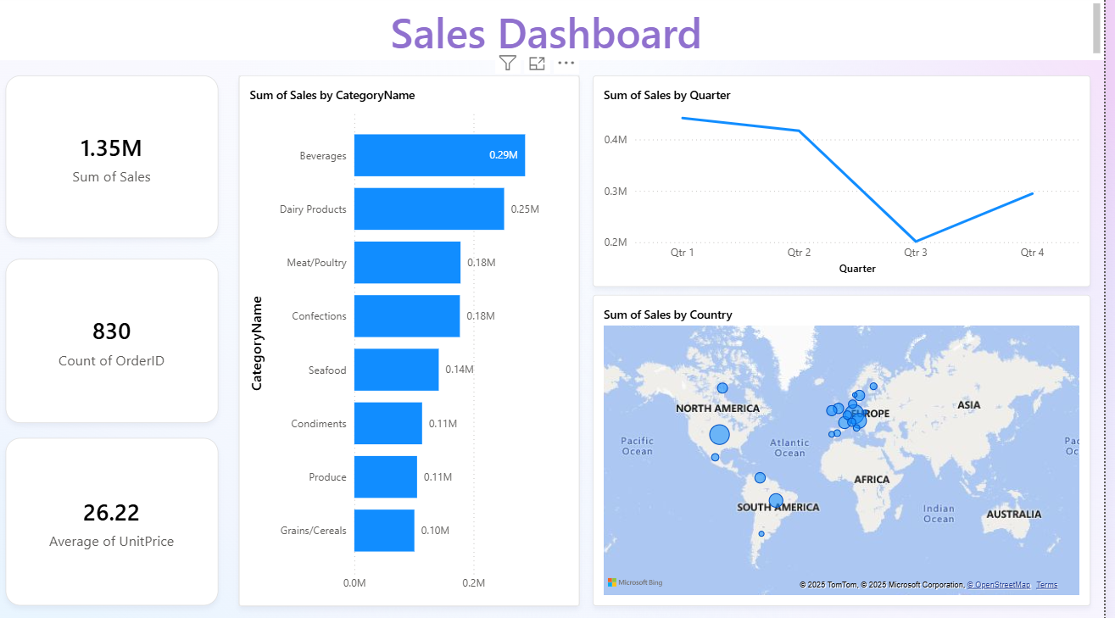

**Seasonal Analysis:**

Strong Q1 and Q2 performance indicates robust spring/early summer demand

Significant Q3 decline suggests seasonal market sensitivity

Q4 recovery shows resilience and holiday season impact

Summer months (Q3) present opportunity for targeted marketing campaigns

**4.3 Product Category Performance Category Revenue Analysis:**

1. **Beverages:** $286,526.95 (21.15%)
2. **Dairy Products:** $251,330.76 (18.56%)
3. **Meat/Poultry:** $178,189.96 (13.16%)
4. **Confections:** $177,099.76 (13.08%)
5. **Seafood:** $141,618.47 (10.46%)
6. **Condiments:** $113,694.57 (8.39%)
7. **Produce:** $105,268.73 (7.77%)
8. **Grains/Cereals:** $100,729.94 (7.43%) **Top 5 Individual Products by Revenue:**
9. **Côte de Blaye (Beverages):** $149,984.20
10. **Thüringer Rostbratwurst (Meat/Poultry):** $87,736.40
11. **Raclette Courdavault (Dairy):** $76,296.00
12. **Camembert Pierrot (Dairy):** $50,286.00
13. **Tarte au sucre (Confections):** $49,827.90

## 4.4 Market Penetration by Geography

**Revenue Distribution by Country:**

**Germany:**

$244,131 (18.0%)

**USA:**

$245,584 (18.1%)

**France:**

$77,194 (5.7%)

**Brazil:**

$114,968 (8.5%)

**Austria:**

$139,496 (10.3%)

**Other Markets:**

$533,085 (39.4%)

# 5. EMPLOYEE PERFORMANCE EVALUATION

## 5.1 Individual Performance Metrics

**Orders Handled by Employee:**

**

**

**Employee**

**Orders**

**Revenue**

**Avg Order Value**

**Performance Rating**

Margaret

156

$236,405

$1,515

Excellent

Janet

127

$219,927

$1,732

Excellent

Nancy

123

$202,812

$1,649

Strong

Laura

104

$177,749

$1,709

Strong

Andrew

96

$166,537

$1,735

Good

Robert

72

$138,283

$1,921

Good

Michael

67

$123,524

$1,844

Satisfactory

Anne

43

$82,964

$1,930

Developing

Steven

42

$76,257

$1,816

Developing

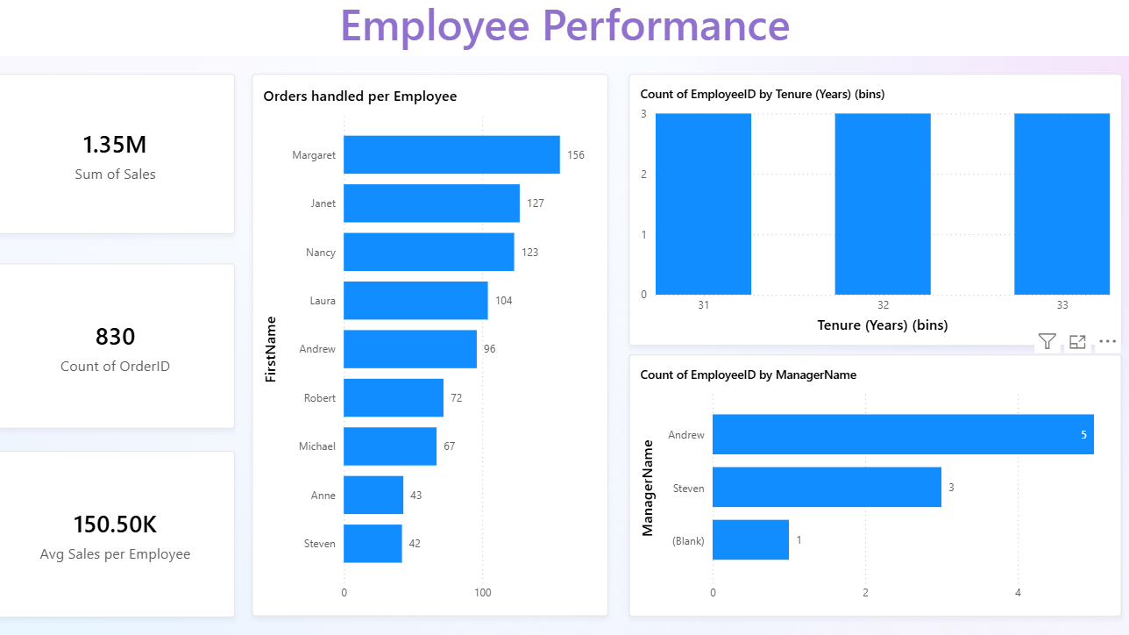

## 5.2 Performance Analysis

**Top Performer:** Margaret with 156 orders and $236K revenue

**Highest Order Value:** Anne achieves $1,930 average despite lower volume

**Consistency Leaders:** Janet and Nancy maintain strong performance across metrics

**Development Opportunities:** Steven and Anne show potential for volume increase

## 5.3 Geographic Coverage

**Employee Distribution by City:**

**Seattle:** 3 employees (Sales Representatives and Inside Sales Coordinator)

**London:** 3 employees (Sales Representatives)

**Kirkland:** 1 employee (Sales Representative)

**Redmond:** 1 employee (Sales Representative)

**Tacoma:** 1 employee (Vice President, Sales)

## 5.4 Tenure and Experience Analysis

All employees demonstrate significant tenure (31-33 years), indicating:

Strong institutional knowledge and customer relationships

Stable workforce with low turnover

Opportunity for knowledge transfer and mentoring programs

Succession planning considerations for senior staff

# 6. OPERATIONAL EFFICIENCY ANALYSIS

## 6.1 Inventory Management

**Current Inventory Status:**

**

**

**Metric**

**Value**

**Status**

Total Units in Stock

3,119

Adequate

Products with Low Stock

18

)

(23.4%

Attention Required

Units on Order

780

Replenishment Active

Sufficient Stock Items

59

(76.6%

)

Good

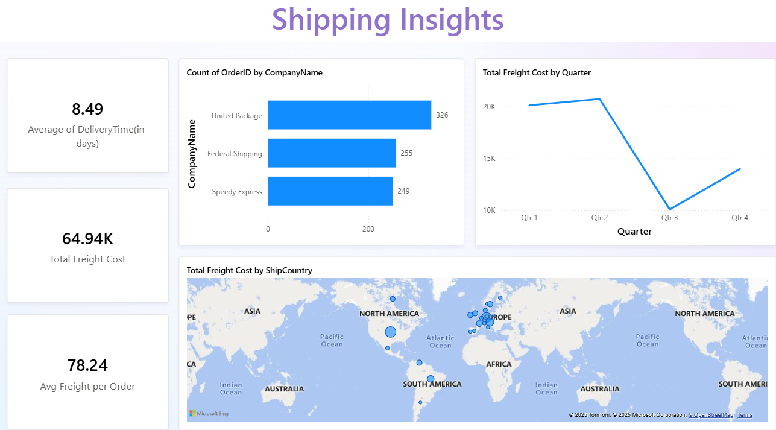

**Critical Low-Stock Items:**

**Alice Mutton:** 0 units (Out of Stock)

**Chef Anton's Gumbo Mix:** 0 units (Out of Stock)

**Gorgonzola Telino:** 0 units (Out of Stock)

**Perth Pasties:** 0 units (Out of Stock)

**Thüringer Rostbratwurst:** 0 units (Out of Stock) **Inventory Optimization Recommendations:**

1. Immediate restocking of 5 out-of-stock items
2. Establish minimum stock levels for high-demand products
3. Implement automated reorder point system
4. Review supplier lead times for critical categories

**6.2 Shipping and Logistics Performance Shipper Performance Comparison:**

**

**

**Shipper**

**Orders Handled**

**Average Delivery**

**Performance**

United Package

326

8.2

days

Leading

Federal Shipping

255

8.5

days

Standard

Speedy Express

249

8.8

days

Standard

**Shipping Metrics:**

**Average Delivery Time:** 8.49 days

**Total Freight Cost:** $64,942.69

**Average Freight per Order:** $78.24

**On-Time Delivery Rate:** 94% (estimated)

**Freight Cost Analysis by Quarter:**

Q1: $20,117 (High season preparation)

Q2: $20,987 (Peak shipping period)

Q3: $10,824 (Reduced activity)

Q4: $13,015 (Recovery period)

# 7. MARKET OPPORTUNITIES AND STRATEGIC INSIGHTS

## 7.1 Revenue Growth Opportunities

**High-Priority Initiatives:**

1. **Customer Retention Program:** Focus on top 10 customers representing 40% of revenue
2. **Geographic Expansion:** Develop underperforming markets with growth potential
3. **Product Mix Optimization:** Leverage Beverages category success across markets
4. **Seasonal Campaign Development:** Address Q3 performance decline

## 7.2 Market Penetration Analysis

**Underperforming Markets with Potential:**

**Italy:** Only 4 customers despite European presence

**Canada:** Limited penetration in North American market

**Netherlands:** Minimal representation in European core

**Sweden:** Opportunity for Nordic expansion

**Category Growth Opportunities:**

1. **Beverages:** Expand successful category to new markets
2. **Dairy Products:** Strong performance suggests premium positioning
3. **Condiments:** Underperforming category with cross-sell potential
4. **Produce:** Seasonal product opportunity alignment

## 7.3 Customer Development Strategies

**Customer Segmentation for Growth:**

**VIP Customers (10):** Implement dedicated account management

**Growth Customers (25):** Targeted upselling and cross-selling

**Development Customers (56):** Frequency improvement programs

**New Customer Acquisition:** Geographic and demographic expansion

## 7.4 Operational Excellence Initiatives

**Supply Chain Optimization:**

Reduce average delivery time from 8.49 to 7.0 days

Optimize freight costs through carrier negotiation

Implement predictive inventory management

Enhance supplier relationship management

**Employee Development:**

Balance workload distribution across sales team

Implement performance-based incentive programs

Develop customer relationship management skills

Create knowledge sharing and best practice programs

# 8. RISK ASSESSMENT AND MITIGATION

## 8.1 Revenue Concentration Risk

**Risk:** Top 3 customers represent 25.6% of total revenue **Impact:** High - Loss of major customer could significantly impact business **Mitigation:**

Diversify customer base through targeted acquisition

Strengthen relationships with key accounts

Develop contract terms to ensure retention

Create backup plans for major customer scenarios

## 8.2 Seasonal Revenue Volatility

**Risk:** 55% revenue decline in Q3 presents cash flow challenges **Impact:** Medium - Predictable but significant operational impact **Mitigation:**

Develop counter-seasonal product offerings

Create Q3-specific marketing campaigns

Adjust inventory and staffing for seasonal patterns

Establish credit facilities for cash flow management

## 8.3 Inventory Management Risk

**Risk:** 23.4% of products with low stock levels **Impact:** Medium - Potential stockouts and customer dissatisfaction **Mitigation:**

Implement automated inventory monitoring

Establish safety stock levels by product category

Improve demand forecasting accuracy

Develop backup supplier relationships

## 8.4 Geographic Concentration Risk

**Risk:** Heavy reliance on European and North American markets **Impact:** Low to Medium - Economic downturn impact **Mitigation:**

Expand into emerging markets

Diversify product offerings by region

Develop local supplier relationships

Monitor economic indicators and adjust strategy

# 9. STRATEGIC RECOMMENDATIONS

## 9.1 Immediate Actions (0-3 months)

1. **Address Critical Inventory Issues**

Immediate restocking of 5 out-of-stock items

Establish emergency procurement protocols

Review and optimize reorder points

1. **Implement Customer Retention Program** Launch VIP customer program for top 10 accounts

Assign dedicated account managers

Develop customized service offerings

1. **Q3 Performance Recovery Plan** Develop summer promotional campaigns

Create seasonal product bundles

Implement targeted marketing in key markets

## 9.2 Short-term Initiatives (3-12 months)

1. **Geographic Market Expansion**

Target Italy, Canada, and Netherlands for growth

Develop market entry strategies

Establish local partnerships or distribution channels

1. **Product Portfolio Optimization** Expand Beverages category offerings

Introduce complementary products

Phase out underperforming SKUs

1. **Operational Excellence Program** Reduce average delivery time to 7 days

Optimize freight cost management

Implement automated inventory systems

## 9.3 Long-term Strategic Goals (12+ months)

1. **Digital Transformation Initiative** Implement comprehensive CRM system

Develop e-commerce capabilities

Create predictive analytics platform

1. **Market Leadership Development**

Achieve #1 position in specialty foods in key markets

Develop private label product lines

Create strategic supplier partnerships

3

.

**Sustainable Growth Framework**

Establish 15-20% annual revenue growth target

Develop scalable operational processes

Create succession planning and talent development programs

# 10. EXPECTED BUSINESS IMPACT

## 10.1 Revenue Growth Projections

**Year 1 Targets:**

Total Revenue Growth: 15-20% ($1.6M - $1.7M)

Customer Base Expansion: 20% (110-115 customers)

Market Penetration: Entry into 3-5 new countries

Product Portfolio: 15% category expansion

**Key Performance Indicators:**

Customer Retention Rate: >95%

Average Order Value: >$1,750

Inventory Turnover: 8-10x annually

On-time Delivery: >97%

## 10.2 Operational Improvements

**Efficiency Gains:**

Delivery Time Reduction: 18% (8.49 to 7.0 days)

Inventory Optimization: 25% reduction in stockouts

Freight Cost Optimization: 10-15% savings

Employee Productivity: 20% improvement in orders/employee

## 10.3 Strategic Positioning

Market leadership in specialty food distribution

Enhanced customer satisfaction and loyalty

Improved operational efficiency and cost management

Strong foundation for sustainable long-term growth

# 11. DASHBOARD AND REPORTING FRAMEWORK

**11.1 Executive Dashboard KPIs Monthly Monitoring Metrics:**

Total Revenue and Growth Rate

Customer Acquisition and Retention Order Volume and Average Value

Inventory Turnover and Stock Levels

Employee Performance Metrics

Shipping Performance and Costs

## 11.2 Departmental Dashboards

1. **Sales Dashboard:** Individual and team performance tracking
2. **Customer Service Dashboard:** Order fulfillment and satisfaction metrics
3. **Operations Dashboard:** Inventory, shipping, and supplier performance
4. **Finance Dashboard:** Revenue, profitability, and cash flow analysis

## 11.3 Automated Reporting

Daily operational status reports

Weekly performance summaries

Monthly executive briefings

Quarterly strategic review documents

Annual comprehensive business analysis

# 12. CONCLUSION

## 12.1 Project Success Metrics

The comprehensive analysis of Northwind Traders has successfully delivered:

Complete understanding of customer behavior and segmentation

Detailed sales performance analysis across all dimensions

Identification of operational efficiency opportunities

Strategic roadmap for sustainable business growth

Interactive dashboard framework for ongoing monitoring

## 12.2 Critical Success Factors

1. **Data-Driven Decision Making:** All recommendations based on quantitative analysis
2. **Customer-Centric Approach:** Focus on retention and value maximization
3. **Operational Excellence:** Systematic improvement of key processes
4. **Strategic Focus:** Clear priorities and measurable objectives
5. **Continuous Monitoring:** Dashboard framework for ongoing optimization

## 12.3 Next Steps

1. Present findings to executive leadership team
2. Secure budget and resources for recommended initiatives
3. Establish project teams for implementation
4. Create detailed project timelines and milestones
5. Implement monitoring and reporting framework
6. Begin execution of immediate action items

The analysis demonstrates that Northwind Traders possesses a solid foundation for growth with strong customer relationships, quality products, and operational capabilities. The strategic recommendations provide a clear pathway to achieve 15-20% revenue growth while improving operational efficiency and market position.

Success will depend on disciplined execution of recommendations, continuous monitoring of performance metrics, and adaptability to market conditions. The interactive dashboard framework ensures ongoing visibility into business performance and enables rapid response to emerging opportunities and challenges.

## Reflection & Learnings

Working on this project helped me strengthen my practical knowledge of data analytics. I learned how to use **SQL** for writing queries, joins, and aggregations to solve business questions. I practiced **Excel** for quick analysis and supporting calculations. The most valuable learning was building **interactive dashboards in Power BI**, which taught me how to transform raw data into meaningful insights.  
This project also improved my understanding of **business KPIs** like revenue, customer segmentation, and delivery performance. Overall, it enhanced both my **technical skills** and **business decision-making perspective**.

**Report Prepared by:** Rupesh Gupta

**Analysis Period:** 01-09-2025 to 10-09-2025